Supplementary information: starch storage strategy in the stem wood influences carbon dynamics and storage-growth trade-offs in tropical trees

David Herrera-Ramírez1*, Christine Römermann2,3, Henrik Hartmann1, Susan Trumbore1, Jan Muhr1, 4, Leonardo Maracahipes-Santos7, Paulo Brando5, 6,7, Divino Silvério8, Huang Jianbei1, Iris Kuhlmann1 and Carlos A. Sierra1

1Max Planck Institute for Biogeochemistry, Hans-Knöll-Str 10, 07745 Jena

2Friedrich Schiller University Jena, Institute for Ecology and Evolution, Philosophenweg 16, 07743, Jena, Germany

3German Centre for Integrative Biodiversity Research (iDiv) Halle-Jena-Leipzig, D- 04103 Leipzig

4Georg August University Göttingen, Department of Bioclimatology, Büsgenweg 2, 37077 Göttingen, Germany

5Department of Earth System Science, University of California, Irvine, CA 92697, USA

6Yale School of the Environment, Yale University, New Haven, CT, United States.

**7**Instituto de Pesquisa Ambiental da Amazônia, Brasília, DF 70863-520, Brazil

8Department of Biology, Universidade Federal Rural da Amazônia-UFRA, Capitāo Poço 68650-000, Pará, Brazil

Dacryodes microcarpa (semi-deciduous/fiber-storing species)

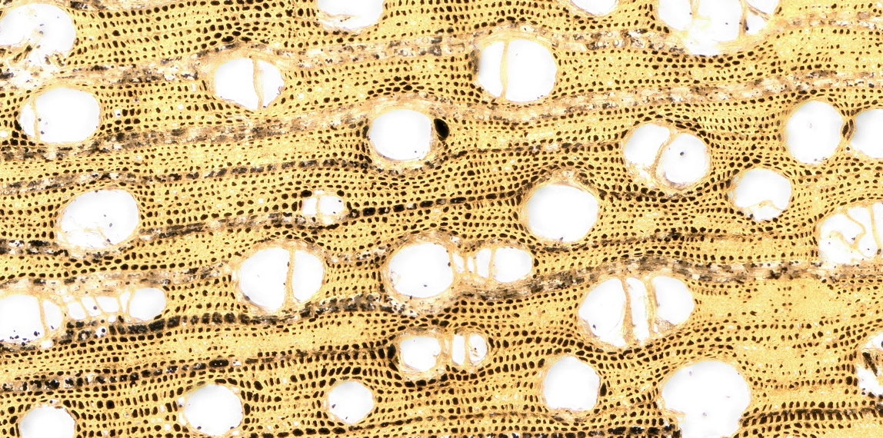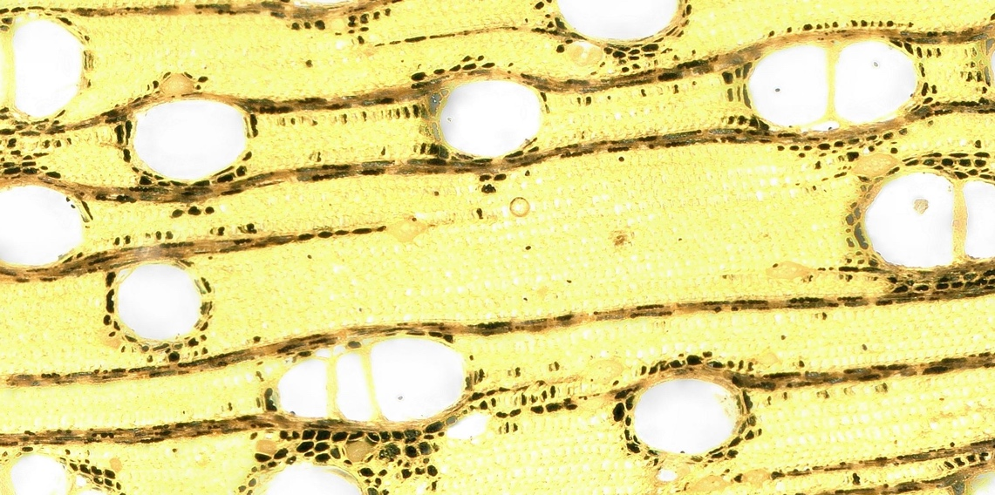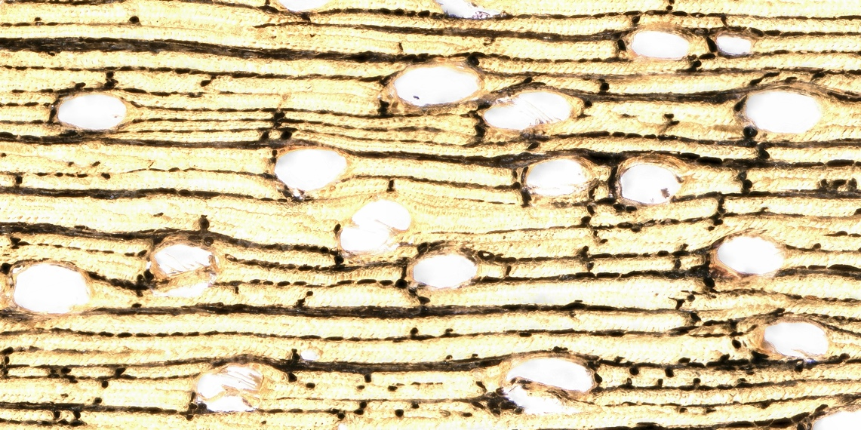

Sacoglotis guianensis (semi-deciduous/parenchyma-storing species)

Ocotea leucoxylon (evergreen/parenchyma-storing species)

Figure S1: Microscopic photos of the transversal section of wood stained with luglo’s iodine for each species. Starch appears stained as black areas and it shows the differences in storage strategies between the species.

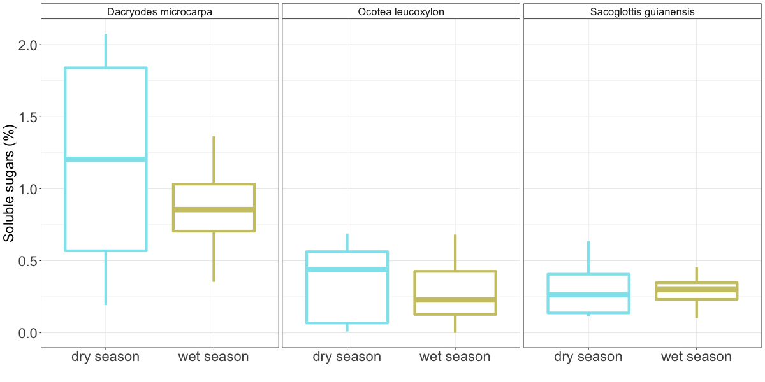

*Figure S2: Boxplots that show the dispersion of the soluble sugar concentration measured in the wood cores from trees of each evaluated species at different seasons during 2018. No difference was detected between seasons for any of the species.*

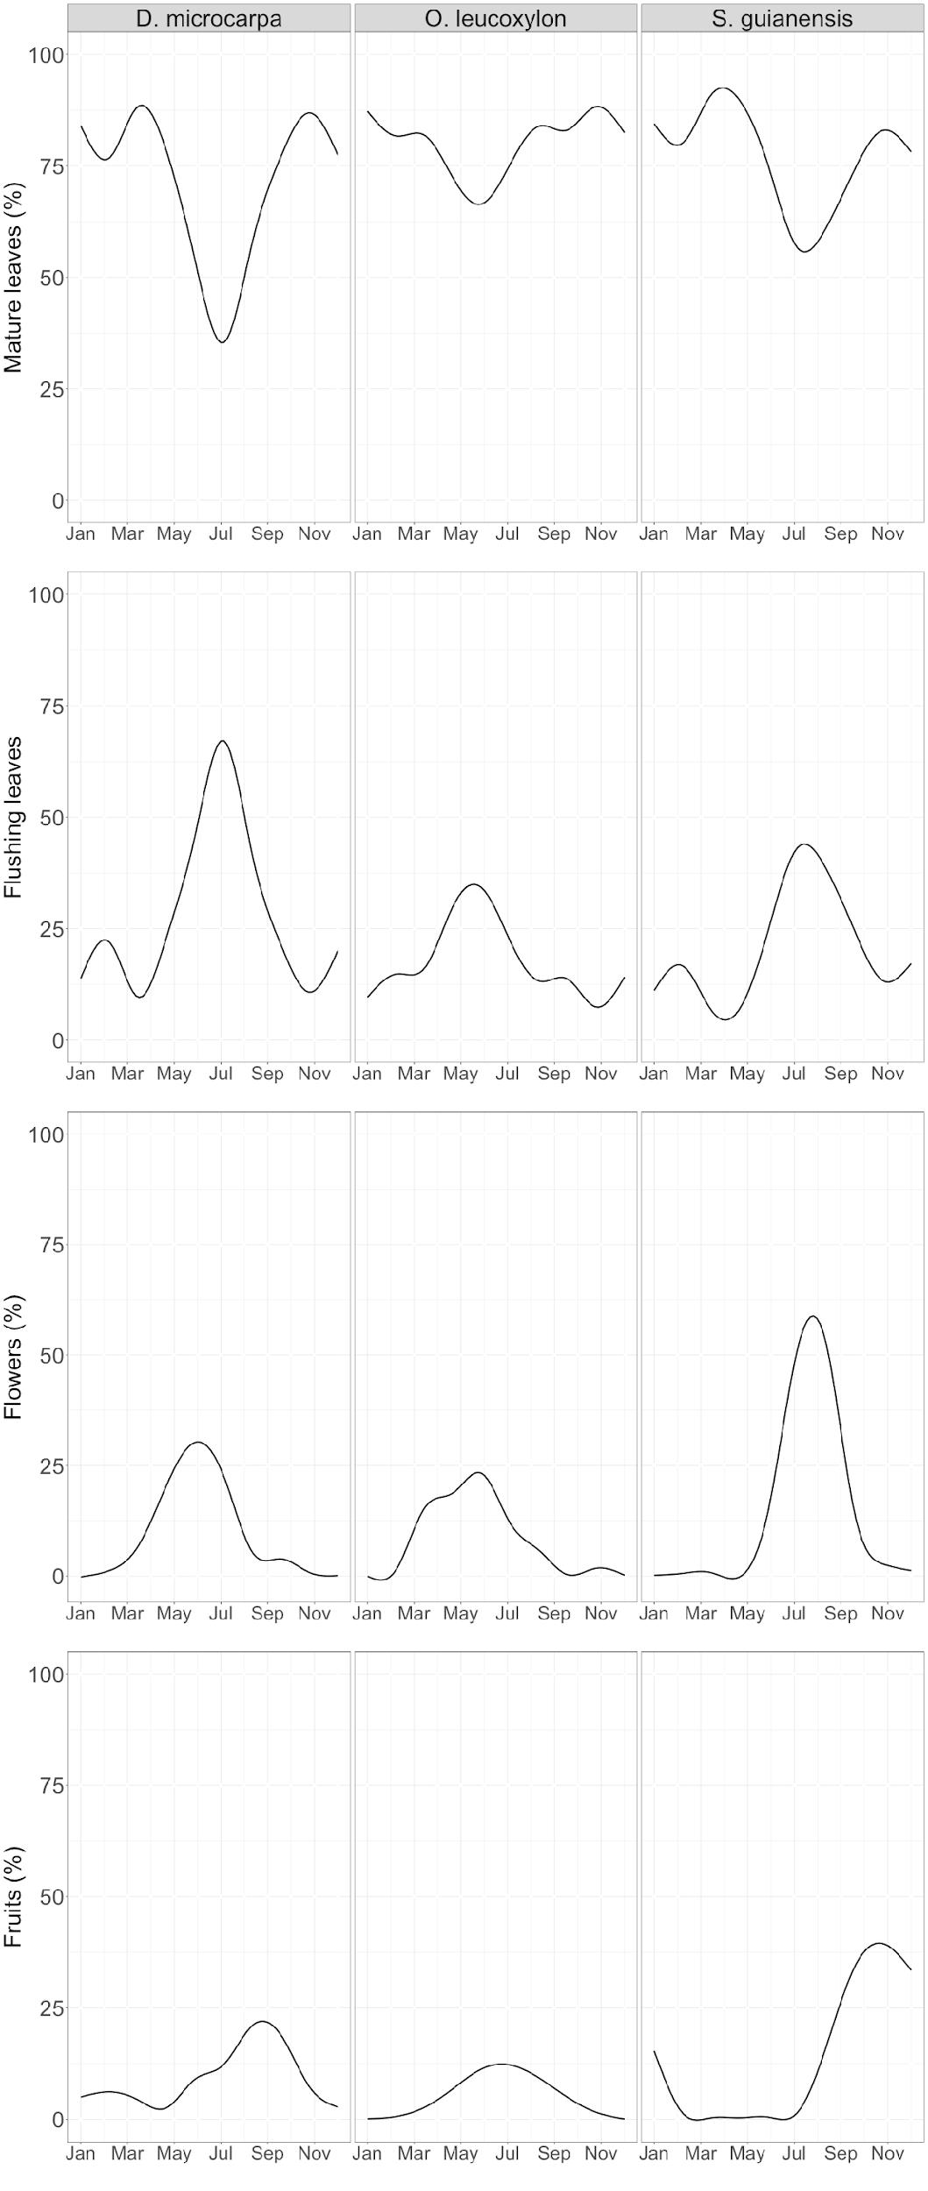

*Figure S3: Seasonality of mature leaves, flushing leaves, flowers and fruits observed during the last 8 years in local trees from the studied species.*

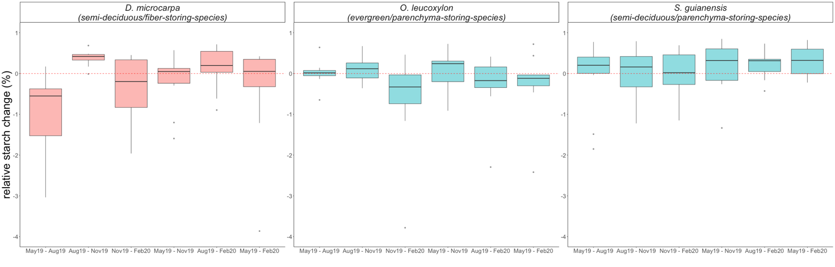

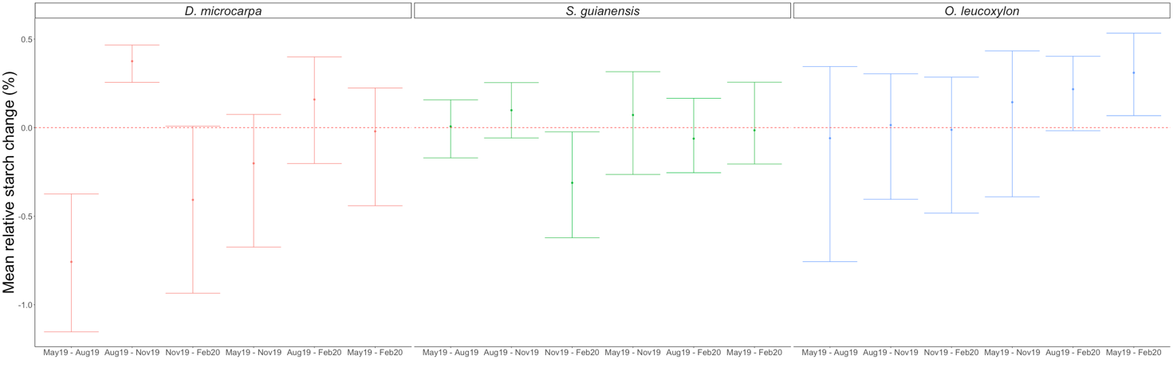

*Figure S4. Upper panel) Relative changes of starch content between months for all the specie analyzed and all the dates collected. And lower panel) a non-parametric confidence interval for the mean of the relative changes of starch content for all the species and all the sampling dates.*

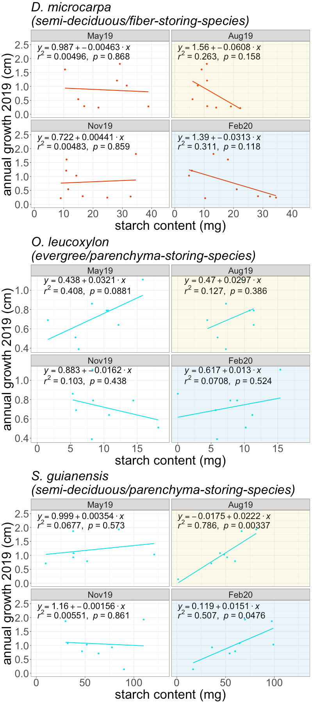

*Figure S5: Relationship between annual growth and the starch content at different times of the year for each of the species studied. The yellow shaded panels correspond to the dry season, while the blue shaded panels correspond to the wet season.*